**Lab Assignment – 14.3**

**Task – 01 :**

**Prompt :-**



**Code :-**

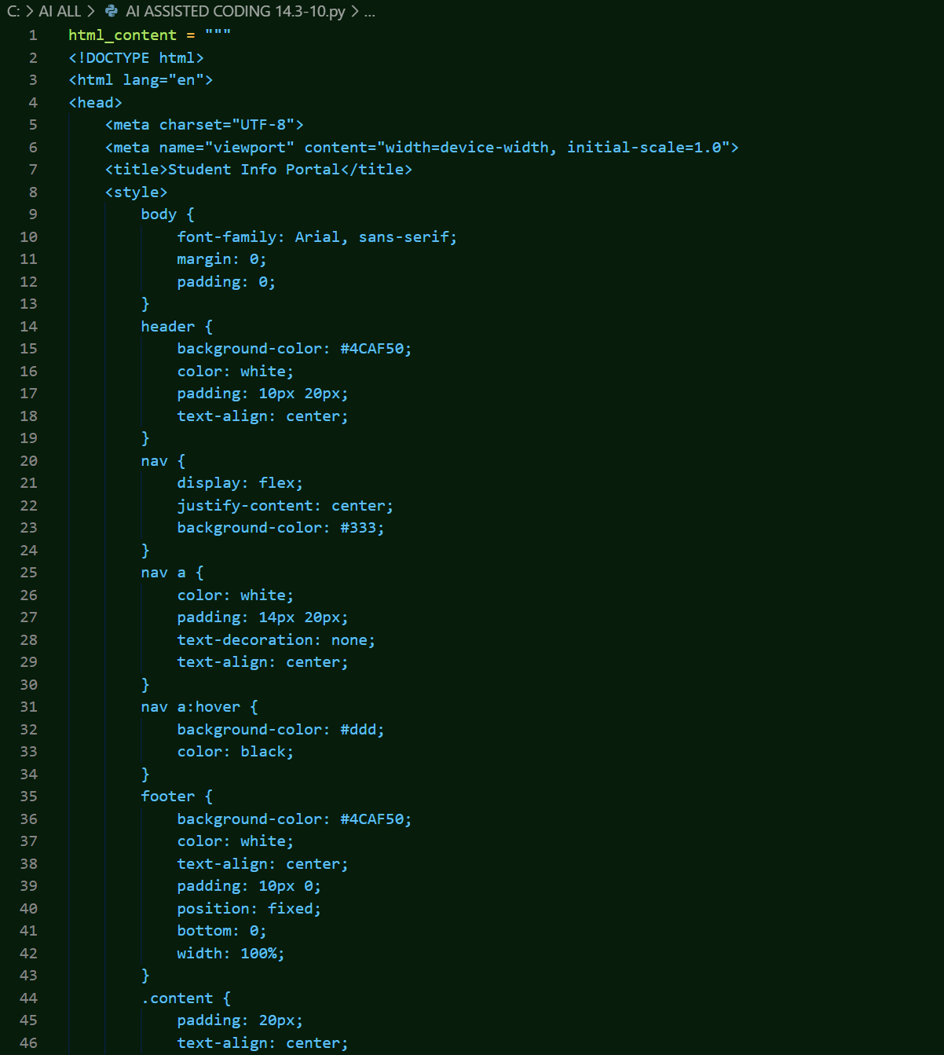

**Output :-**

**Task 02 :**

**Prompt :-**

**Code :-**

**Output :-**

**Task 03 :-**

**Prompt :-**

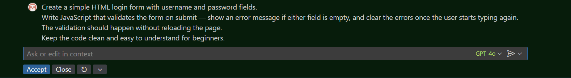

**Code:-**

**Task 04 :-**

**Prompt :-**